

Specification

for

SQL diagnostic manager 5.1 – Scheduled Maintenance Mode

Kurt Goolsbee

10/08/2007



Proprietary and Confidential to BBS Technologies, Inc.

© 2006 BBS Technologies, Inc.; all rights reserved.

Revision history:
When? | Who? | What?
10/08/2007 | Kurt Goolsbee | Initial Draft

Table of Contents
1. Revision history: ii
2. Table of Contents iii
3. Requirements 1
3.1. Overview/Purpose 1
3.2. Glossary 1
3.3. Major Features 1
3.3.1. Recurring Scheduled Maintenance Mode 1
3.3.2. One-time Scheduled Maintenance Mode 1
3.4. Open Issues 2
4. Functional Design 2
4.1. User Interface 2
4.2. Installation and Upgrade 4
4.3. Permissions and other Required Configuration 5
4.4. Licensing Issues 5
4.5. Dependencies 5
4.5.1. Dependencies on Idera Software 5
4.5.2. Third-Party Software Required on the Customer Machine 5
4.5.3. Third-Party Software Required Internally 5
5. Internal Design 5
5.1. Architecture 5
5.2. Installation Issues 6
5.3. Schedule 6
5.3.1. Work Breakdown and Sizings 6
5.3.2. Areas of Risk 6
6. Quality Assurance Considerations 6
6.1.1. Overview 6
6.1.2. Developer-Created Unit Tests 7
7. Documentation Considerations 7
8. Bibliography 7

Requirements

Overview/Purpose
In SQL diagnostic manager 5.0, the user is able to put a monitored server into maintenance mode and to take a monitored server out of maintance mode using the Desktop Client on a per server basis. Customers would like the ability to specify a schedule for when a server should be in maintenance mode.

Glossary
- Management Service – The service that functions as the central aggregator for the SQL diagnostic manager architecture.
- Collection Service – The service that collects metrics from a set of monitored servers and transmits those metrics to the Management Service.
- SQLdm Repository – The central repository used for storing scheduled collection snapshots and configuration information for the SQL diagnostic manager architecture.
- Desktop Client – The client application for viewing SQL diagnostic manager data, configuring monitored servers, etc…
- Scheduled Collection – The act of collecting snapshots on a scheduled basis. These scheduled collections can trigger notifications and some of the data points are stored in the SQLdm Repository.
- On-Demand Collection – The act of a client requesting current data for a monitored server. This happens as a result of a user opening up a view in a client. Not all client views use On-Demand data. Once a user has an On-Demand view open, On-Demand data is requested for that view at a interval specified on the client.
- Maintenance Mode – When a monitored server is in maintenance mode the collection service will not perform scheduled collection and will not raise events (Alerts) for that server.

Major Features

Recurring Scheduled Maintenance Mode
Allow the user to specify the days of the week, time of day and number of hours that a monitored server will be in maintenance mode. The monitored server will be placed in maintenance mode on the specified days during the configured time period.

One-time Scheduled Maintenance Mode
Allow the user to specify a start and end date/time that a monitored server will be in maintenance mode. The monitored server will only be in maintenance mode during this time period.

Open Issues
Should the duration for scheduled maintenance mode be scheduled in hour increments or should we allow the duration to be specified as hours and minutes?
We will allow all time fields used in the maintenance mode schedule to be entered as hours and minutes.

Functional Design

User Interface
The user interface for configuring maintenance mode will be a single dialog that is launched from the desktop client using a context menu option, available on a monitored server object, in the server tree. In addition the dialog can be accessed via the “Maintenance Mode” button on the Overview tab of the ribbon. All schedule times will be in the local time of the monitored server.
The dialog will allow the user to select 1 of 4 maintenance mode configurations.
- Never – The server will be taken out of maintenance mode and scheduled collection will resume.
- Until further notice – The server will be put in maintenance mode until another maintenance mode is selected.
- Recurring schedule – The server will be in maintenance mode on the days of the week and time specified. Additional controls will be enabled to allow the user to select the days of the week, start time and number of hours + minutes for the server to be in maintenance mode.
- One-time schedule – The server will be in maintenance mode during the time specified. Additional controls will be enabled to allow the user to select a start and end date/time for the server to be in maintenance mode.
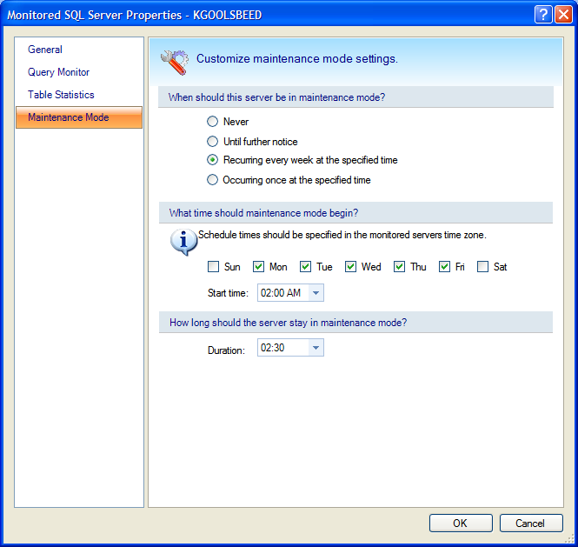
Sample property page for setting recurring scheduled maintenance mode. The layout of the page will change based on the selected radio button. If ‘Never’ or ‘Until Further Notice’ is selected the rest of the controls on the page will be disabled.

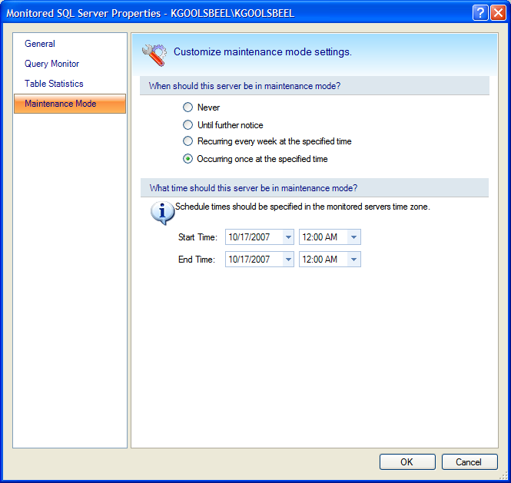
Sample property page for setting one time scheduled maintenance mode. The layout of the page will change based on the selected radio button. If ‘Never’ or ‘Until Further Notice’ is selected the rest of the controls on the page will be disabled.

Installation and Upgrade
There are no specific install considerations. After an upgrade, all servers that were in maintenance mode at the time of the upgrade will show as being in maintenance mode ‘Until further notice’ and all others will show as ‘Never.
An upgrade of the repository will be required due to the additional columns will be necessary to store the maintenance mode schedule.

Permissions and other Required Configuration
If we add the feature for Application Security in 5.1 then we will need to make sure the actions for setting maintenance mode are only available for users with Full-Access or Administrator privileges.

Licensing Issues
None.

Dependencies

Dependencies on Idera Software
No additional dependencies.

Third-Party Software Required on the Customer Machine
No additional dependencies.

Third-Party Software Required Internally
No additional dependencies.

Internal Design

Architecture
Currently maintenance mode is either Disabled or Enabled until further notice. The change is initiated from the Desktop Client and sent to the Management Service. The Management Service updates a flag in the MonitoredSQLServer table for the selected server. Once the repository is updated the Management Service sends a notification to the Collection Service which causes the Collection Service to drop the configuration for the monitored server. The configuration change will be logged in the tracerx and the application event log.

The new architecture will be similar except that the collection service will no longer drop the configuration for the monitored server. Instead the configuration will get updated with any changes to the maintenance mode options. When the collection service starts a scheduled collection it will check its configuration to determine if the monitored server is in maintenance mode. If the server is in one of the scheduled maintenance modes, it will send a scheduled collection to the management service that has an error set indicating that the collection was skipped because it was in maintenance mode. The Management Service will detect the maintenance mode error and update the repository. The Desktop Clients will show the server in maintenance mode after the next background refresh completes. When the collection service determines that the server is no longer in maintenance mode it will resume normal collection. When the Management Service receives a scheduled collection that no longer has the maintenance mode error set it will update the repository so that the Desktop Clients can determine the new state of the server.

Installation Issues
The repository will require an upgrade.

Schedule

Work Breakdown and Sizings
Component | Who | Sizing
Management Service | Kurt | .5
Collection Service | Kurt | 1
Database | Kurt | .5
Desktop Client | Kurt | 1
Unit and Integration Testing | Kurt | 2
Total |  | 5

Areas of Risk
Inconsistencies between the Repository and the Collection Service. Since the Collection Service does not update the repository directly and if the Management Service can’t be contacted or if the Repository is unavailable to the Management Service then the status of the monitored server in the repository may not be accurate. At some point we may need to add a queue for changes that must be sent to the collection service in order for it to maintain a more consistent state.

Quality Assurance Considerations

Overview
When maintenance mode is changed, there are several places to verify that the change has taken effect. The properties page for the monitored server should show the current maintenance mode settings stored in the repository. The icon in the tree should change to show the current state of the monitored server. The monitored server will also be included in the Maintenance Mode user view only when the server is in maintenance mode. The last place to check is the log file for the collection service. We will log an informational message whenever the configuration for the monitored server is updated and also when a scheduled refresh is skipped because the server is in maintenance mode.

Developer-Created Unit Tests
Test each of the maintenance mode options available in the UI:
Put a server into maintenance mode
Remove the server from maintenance mode
Configure a one-time schedule and monitor for entry and exit from maintenance mode per the schedule
Configure a recurring schedule and monitor for entry and exit from maintenance mode per the schedule
Perform the schedule tests again but once maintenance mode is started by the schedule, disable maintenance mode and verify that maintenance mode got disabled.
Enable the scheduled maintenance mode during the time period that the monitored server should be in maintenance mode and verify that maintenance mode is started.
While the server is in scheduled maintenance mode, update the schedule where the server should still be in maintenance mode. Verify that the server stayed in maintenance mode.
While the server is in scheduled maintenance mode, update the schedule where the server should no longer be in maintenance mode. Verify that the server exited maintenance mode.

Documentation Considerations
The documentation will need to be updated to describe the new scheduling options.

Bibliography

